intro to Deep Learning

Module 1

v-cardona

Using GPUs to Scale and Speed-up Deep Learning

Contenido

Introduction to Deep Learning 2

Deep learning pipeline 2

# Introduction to Deep Learning

First step in building such a model would be “feature extraction and feature selection.” That is, to choose the best features from your images, and then to use those features in a classification algorithm, such as a shallow Neural Network. Convolutional Neural Networks can automatically find those features and classify the images for you.

We can say Deep Learning is an algorithm that learns directly from samples much better than traditional approaches.

# Deep learning pipeline

First, pre-processing input data. Second, training the deep learning model. And third, inference and deployment of the model.

First we have to convert the images into a readable and proper format for our network. Then, an untrained network is fed with a big dataset of images in the Training phase, prompting the network to learn. Finally, we use the trained model in the Inference phase, which classifies a new image by inferring its similarity to the trained model.

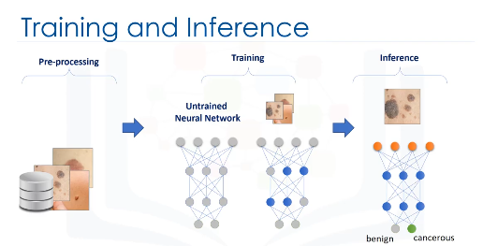

However, we should consider that, in general, this pipeline is very slow for three reasons:

1. First, training a deep neural network is a slow process.
2. Second, building a deep neural network is an iterative process for data scientists, that is, it needs optimization and tuning, and data scientists need to run it many times to make it ready to be used.
3. Third, the trained model needs to be updated periodically, because new data needs to be added to the training set. Because of these factors, the process is generally very slow.

Training time is one of the key components to productivity, and indeed a key metric for deep learning. We can train a model for days and it will have a big accuracy bit when modify a parameter we have to run again and wait several days. However, with a training of little hours we can run the model several times to check the solution, to modify parameters faster and maybe to combine and ensemble models.